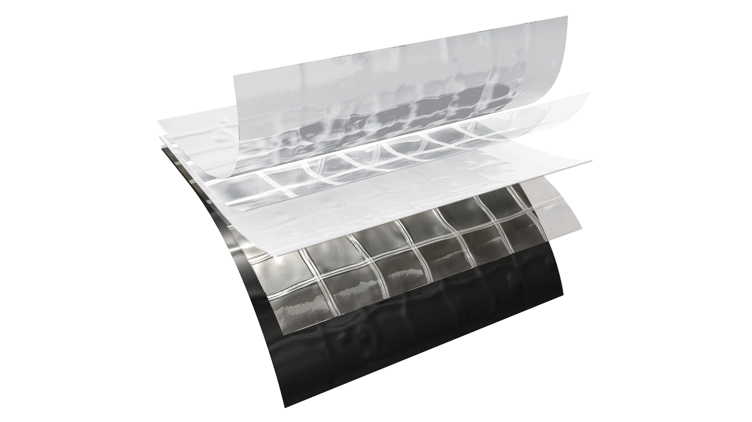

f e a t u r e s a n d b e n e f i t s
TE CHN ICA L D A T A SHE ET
P h y s i c a l p r o p e r t i e s a n d t y p i c a l v a l u e s

griffo lyn ®
type - 90
P r o p e r t y | A s t m t e s t m e t h o d | u . s . v a l u e | m e t r i c v a l u e
Weight | D-751 | 62 LB/1000 FT2 | 30.3 KG/100 M2
3” Load @ Yield | D-882 | 175 LBF | 779 N
3” Load @ Break | D-882 | 90 LBF | 400 N
 |  | 2050 PSI | 14.1 MPA
3” Elongation @ Break | D-882 | 425 % | 425 %
Tongue Tear | D-2261 | 35 LBF | 156 N
Trapezoidal Tear | D-4533 | 44 LBF | 196 N
PPT Resistance | D-2582 | 45 LBF | 200 N
Dart Impact Strength | D-1709 | 3.1 LBS | 1410 G
Cold Impact Strength | D-1790 | -40°F | -40°C
Permeance | E-96 | 0.019 Grain/Hr•Ft2•in.Hg | 1.09 NG/(PA•S•M2)
Radon Permeability | SP Method 3873 |  | 15•10-12 m2/s
Radon Transmittance | SP Method 3873 |  | 42•10-9 m/s

d e s c r i p t i o n
Griffolyn® Type 90 is made with 2 layers of white film and one layer of black film with 2 layers
of reinforcement. It is specifically engineered to provide high strength and durability in a lightweight material.

- Multiple layers and cord reinforcement resist punctures and tears.
- UV stabilization protects the material from degradation during extended exposure to sunlight.
- Cold-crack resistance eliminates failures in cold temperatures.
MORE
- Flexibility and light weight allow for easy handling and quick installation.
- Custom fabrication is available to meet your exact specifications.
- Long life expectancy allows for significant cost savings through reuse and fewer replacements.

OUR CUSTOMERs DON’T JUST cover their business,
THEY PROTECT IT
MADE IN
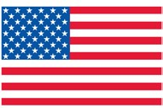
- S. A.

TE CHN ICA L D A T A SHE ET
GRIFFO LYN ®
Type - 90

S u g g e s t e d a p p l i c a t i o n s
  - Pallet, cable reel and drum covers for outside storage.
  - Temporary walls, plant dividers, building enclosures and containment tents.
  - Shipping container covers and liners.
  - Floor covers.
  - Soil covers to control leachate for stockpiles and landfills.
  - Agricultural storage systems, hay covers and windbreaks.
  - Athletic field and equipment covers.
  - Interim landfill covers.

O r d e r i n g I n f o r m a t i o n
AVAILABLE COLORS:
Black/White Reversible

Custom sizes up to 150’ x 200’ and custom fabrication are available to meet your exact specifications.

USABLE TEMPERATURE RANGE:
Minimum: -40°F -40°C Maximum: 170°F 77°C

o u t d o o r e x p o s u r e
Under normal continuous exposure the average life expectancy ranges from 30 to 48 months.

Reef Industries, Inc.
9209 Almeda Genoa Rd. • Houston, Texas 77075 P: 713.507.4251 • F: 713.507.4295
E-mail: ri@reefindustries.com • www.reefindustries.com
toll free 1.800.231.6074
The information provided herein is based upon data believed to be reliable. All testing is performed in accordance with ASTM standards and procedures. All values are typical and nominal and do not represent
either minimum or maximum performance of the product. Although the information is accurate to the best of our knowledge and belief, no representation of warranty or guarantee is made as to the suitability or
completeness of such information. Likewise, no representation of warranty or guarantee, expressed or implied, or merchantability, fitness or otherwise, is made as to product application for a particular use.

©2014 REEF INDUSTRIES, INC. Griffolyn is a registered trademark of Reef Industries, Inc. 4-14

