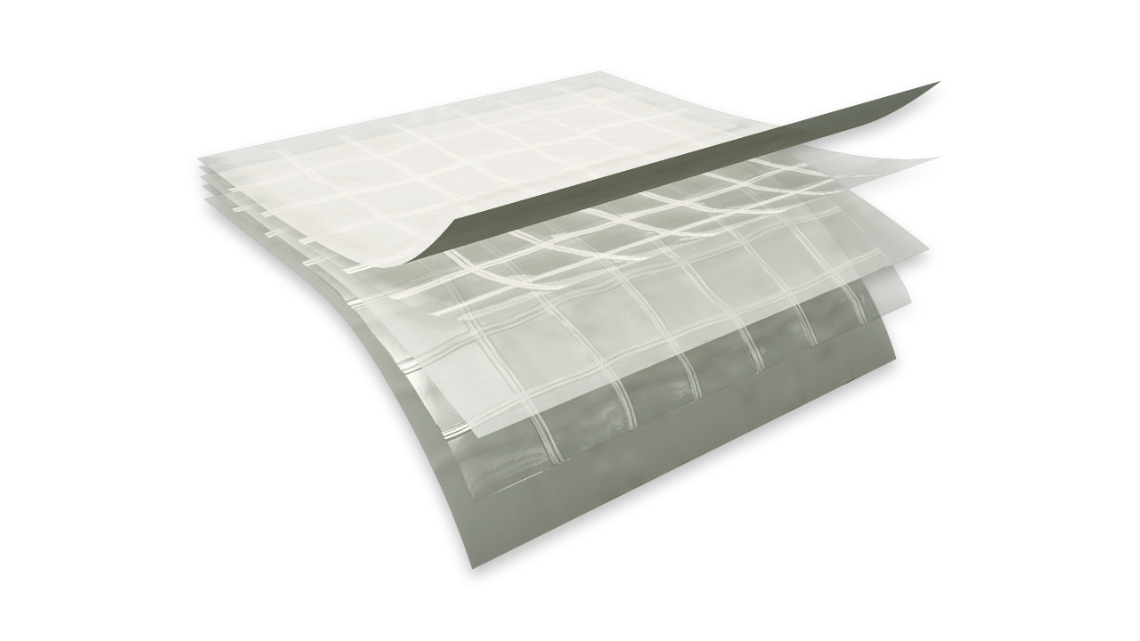

f e a t u r e s a n d b e n e f i t s
TE CHN ICA L D A T A SHE ET
P h y s i c a l p r o p e r t i e s a n d t y p i c a l v a l u e s

griffo lyn ®
type - 90 fr
P r o p e r t y | A s t m t e s t m e t h o d | u . s . v a l u e | m e t r i c v a l u e
Weight | D-3776 | 74 LB/1000 FT2 | 36.1 KG/100 M2
3” Tensile Strength | D-882 | 180 LBF | 801 N
3” Load @ Break | D-882 | 86 LBF | 383 N
 |  | 2000 PSI | 13.8 MPA
3” Elongation @ Break | D-882 | 375 % | 375 %
Tongue Tear | D-882 | 31 LBF | 138 N
Trapezoidal Tear | D-4533 | 50 LBF | 222 N
Puncture Strength | D-4833 | 54 LBF | 240 N
PPT Resistance | D-2582 | 42 LBF | 187 N
Dart Impact Strength | D-1709 | 3.3 LBS | 1500 g
Cold Impact Strength | D-1790 | -40°F | -40°C
Permeance | E-96 | 0.015 Grain/Hr•Ft2•in.Hg | 0.86 NG/(PA•S•M2)
Fire Retardancy | E-84 | 5 flame spread, 90 smoke developed
 | NFPA 701 | Pass

d e s c r i p t i o n
Griffolyn® Type-90 FR is a 5-ply laminate combining three layers of fire retardant, linear low density polyethylene and two high-strength cord grids. It is specifically engineered to provide high strength and durability in a lightweight material.

- Multiple layers and cord reinforcement resist punctures and tears.
- Flexibility and light weight allow for easy handling and quick installation.
- Custom fabrication is available to meet your exact specifications.
MORE
- Long life expectancy allows for significant cost savings through reuse and fewer replacements.

OUR CUSTOMERs DON’T JUST cover their business,
THEY PROTECT IT
MADE IN
- S. A.

TE CHN ICA L D A T A SHE ET
GRIFFO LYN ®
T - 90 fr

C o n f o r m s t o t h e f o l l o w i n g s a f e t y c o d e s :
  - Passes NFPA 701 Test 2 (Large Scale) – “Standard Methods of Fire
Tests for Flame Propagation of Textiles and Films”.

S u g g e s t e d a p p l i c a t i o n s
    - Temporary walls, plant dividers, building enclosures and containment tents.
    - Architectural vapor retarders in walls, ceilings and roofing systems.
    - Floor covers, dust partitions and cleanroom enclosures.
    - Equipment covers.
    - Pallet and custom covers for outside storage.
    - Custom shipping container covers and liners.
    - Environmental covers for waste containment and disposal.
    - Industrial Packaging.

O r d e r i n g I n f o r m a t i o n
AVAILABLE COLORS:
Natural and Green

Custom sizes up to 100’ x 150’ and custom fabrication are available to meet your exact specifications. USABLE TEMPERATURE RANGE:
Minimum: -30°F -32°C Maximum: 170°F 77°C

o u t d o o r e x p o s u r e
Under normal continuous exposure the average life expectancy ranges from 10 to 12 months.

Reef Industries, Inc.
9209 Almeda Genoa Rd. • Houston, Texas 77075 P: 713.507.4251 • F: 713.507.4295
E-mail: ri@reefindustries.com • www.reefindustries.com
toll free 1.800.231.6074
The information provided herein is based upon data believed to be reliable. All testing is performed in accordance with ASTM standards and procedures. All values are typical and nominal and do not represent
either minimum or maximum performance of the product. Although the information is accurate to the best of our knowledge and belief, no representation of warranty or guarantee is made as to the suitability or
completeness of such information. Likewise, no representation of warranty or guarantee, expressed or implied, or merchantability, fitness or otherwise, is made as to product application for a particular use.

©2012 REEF INDUSTRIES, INC. Griffolyn is a registered trademark of Reef Industries, Inc. 10-12

