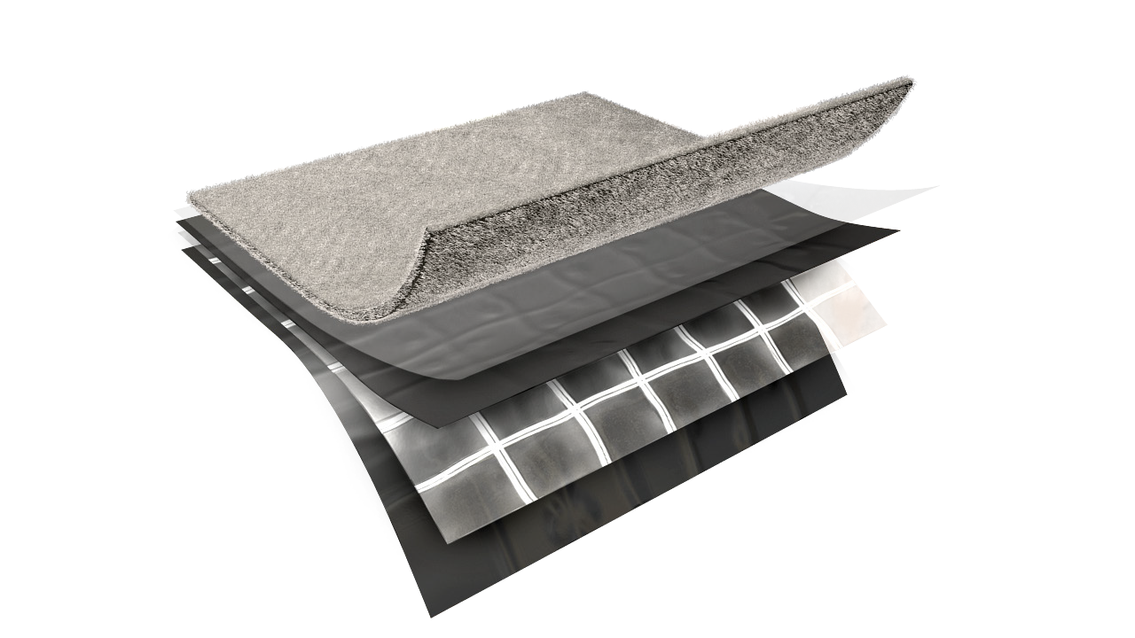

f e a t u r e s a n d b e n e f i t s
TE CHN ICA L D A T A SHE ET
P h y s i c a l p r o p e r t i e s a n d t y p i c a l v a l u e s

griffo lyn ®
type - 65 g
P r o p e r t y | A s t m t e s t m e t h o d | u . s . v a l u e | m e t r i c v a l u e
Weight | D-3776 | 82 LB/1000 FT2 | 40.1 KG/100 M2
3” Tensile Strength | D-882 | 190 LBF | 845 N
Puncture Strength | D-4833 | 60 LBF | 267 N
PPT Resistance | D-2582 | 62 LBF | 276 N
Dart Impact Strength | D-1709 | 5 LBS | 2270 g
Cold Impact Strength | D-1790 | -40°F | -40°C
Permeance | E-96 | 0.038 Grain/Hr•Ft2•in.Hg | 2.125 NG/(PA•S•M2)

d e s c r i p t i o n
Griffolyn® Type-65 G is a 3-ply laminate combining two layers of high density polyethylene and a high-strength cord grid with a layer of non-woven geotextile fiber. It is
specifically engineered to provide high strength and durability in a lightweight material.

- Multiple layers and cord reinforcement combined with the geotextile layer offer extremely high puncture and tear resistance.
- UV stabilization protects the material from degradation during extended exposure to sunlight.
- Cold-crack resistance eliminates failures in extremely cold temperatures.
- Low permeability greatly inhibits moisture transmission.
- Flexibility and light weight allow for easy handling and quick installation.
- Custom fabrication is available to meet your exact specifications.
- Class A, ASTM E-1745-11 Standard Specification for Water Vapor Retarders Used in Contact With Soil or Granular Fill Under Concrete Slabs.
MORE

OUR CUSTOMERs DON’T JUST cover their business,
THEY PROTECT IT
MADE IN
U. S. A.

TE CHN ICA L D A T A SHE ET
GRIFFO LYN ®
Type - 65 G

S u g g e s t e d a p p l i c a t i o n s
Architectural vapor retarder under slab on grade.

O r d e r i n g I n f o r m a t i o n
AVAILABLE COLORS:
Black

SIZES:
Rolls are available from 4’ x 100’ to 40’ x 100’ in increments of 4’ widths. Some sizes available for immediate shipment. Standard length and width tolerances are ± 1% (minimum 2”)
Custom sizes up to 100’ x 100’ and custom fabrication are available to meet your exact specifications. USABLE TEMPERATURE RANGE:
Minimum: -25°F -31.6°C
Maximum: 170°F 77°C

o u t d o o r e x p o s u r e
Under normal continuous exposure the average life expectancy ranges from 18 to 30 months, depending on color.

Reef Industries, Inc.
9209 Almeda Genoa Rd. • Houston, Texas 77075 P: 713.507.4251 • F: 713.507.4295
E-mail: ri@reefindustries.com • www.reefindustries.com
toll free 1.800.231.6074
The information provided herein is based upon data believed to be reliable. All testing is performed in accordance with ASTM standards and procedures. All values are typical and nominal and do not represent
either minimum or maximum performance of the product. Although the information is accurate to the best of our knowledge and belief, no representation of warranty or guarantee is made as to the suitability or
completeness of such information. Likewise, no representation of warranty or guarantee, expressed or implied, or merchantability, fitness or otherwise, is made as to product application for a particular use.

©2012 REEF INDUSTRIES, INC. Griffolyn is a registered trademark of Reef Industries, Inc. 10-12

