-

TE CHN ICA L D A T A SHE ET

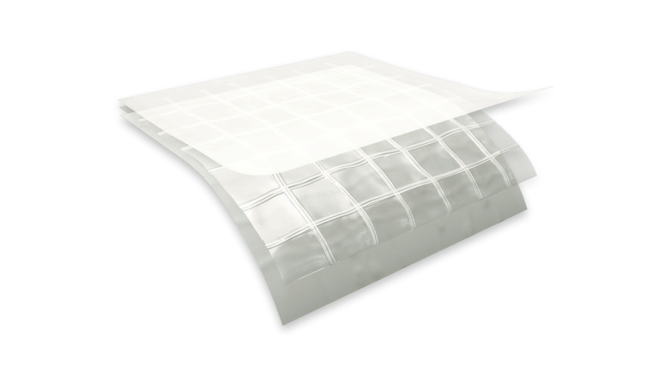
d e s c r i p t i o n
Griffolyn® Type-55 FR is a 3-ply laminate combining two layers of fire retardant low density polyethylene and a high-strength cord grid. It is specifically engineered to provide high strength and durability in a lightweight material.
P h y s i c a l p r o p e r t i e s a n d t y p i c a l v a l u e s

P r o p e r t y | A s t m t e s t m e t h o d | u . s . v a l u e | m e t r i c v a l u e
Weight | D-3776 | 33 LB/1000 FT2 | 16.1 KG/100 M2
3” Tensile Strength | D-882 | 90 LBF | 400 N
3” Load @ Break | D-882 | 36 LBF | 160 N
 |  | 2000 PSI | 13.8 MPA
Tongue Tear | D-751 B | 14 LBF | 62 N
Trapezoidal Tear | D-4533 | 26 LBF | 116 N
PPT Resistance | D-2582 | 26 LBS | 116 N
Dart Impact Strength | D-1709 | 0.90 LBS | 410 G
Cold Impact Strength | D-1790 | -20°F | -28.9°C
Permeance | E-96 | 0.062 Grain/Hr•Ft2•in.Hg | 3.556 NG/(PA•S•M2)
Fire Retardancy | E-84 | 5 flame spread, 35 smoke developed
 | NFPA 701 | Pass

f e a t u r e s a n d b e n e f i t s
- Fire retardant to meet safety requirements in critical equipment and material areas.
- Multiple layers and cord reinforcement resist punctures and tears.
- Cold-crack resistance eliminates failures in extremely cold temperatures.
- Low permeability greatly inhibits moisture transmission.
- Flexibility and light weight allow for easy handling and quick installation.
- Custom fabrication is available to meet your exact specifications.
MORE
- High durability allows for significant savings through reuse and fewer replacements.

OUR CUSTOMERs DON’T JUST cover their business,
griffo lyn ®
type - 55 fr
THEY PROTECT IT
MADE IN
- S. A.

TE CHN ICA L D A T A SHE ET
GRIFFO LYN ®
Type - 55 fr

S u g g e s t e d a p p l i c a t i o n s
  - Temporary walls, plant dividers, building enclosures and containment tents.
  - Shipping container covers and liners.
  - Floor covers, dust partitions and cleanroom enclosures.
  - Bags and tubing (printing available).
  - Industrial Packaging.
  - Custom covers and outside storage.
  - Architectural vapor retarder in walls, ceilings and in roofing systems.

O r d e r i n g I n f o r m a t i o n
AVAILABLE COLORS:
Natural, Yellow and Green

Custom sizes up to 100’ x 125’ and custom fabrication are available to meet your exact specifications. USABLE TEMPERATURE RANGE:
Minimum: -5°F -20°C Maximum: 150°F 66°C

o u t d o o r e x p o s u r e
Under normal continuous exposure the average life expectancy ranges from 10 to 12 months, depending on color.

C o n f o r m s t o t h e f o l l o w i n g s a f e t y c o d e s :
  - Passes NFPA 701 Test 2 (Large Scale) – “Standard Methods of Fire Tests for Flame Propagation of Textiles and Films”.
  - Class I, Class A flame spread rating per UBC-42 and ASTM E-84.

Reef Industries, Inc.
9209 Almeda Genoa Rd. • Houston, Texas 77075 P: 713.507.4251 • F: 713.507.4295
E-mail: ri@reefindustries.com • www.reefindustries.com
toll free 1.800.231.6074
The information provided herein is based upon data believed to be reliable. All testing is performed in accordance with ASTM standards and procedures. All values are typical and nominal and do not represent
either minimum or maximum performance of the product. Although the information is accurate to the best of our knowledge and belief, no representation of warranty or guarantee is made as to the suitability or
completeness of such information. Likewise, no representation of warranty or guarantee, expressed or implied, or merchantability, fitness or otherwise, is made as to product application for a particular use.

©2012 REEF INDUSTRIES, INC. Griffolyn is a registered trademark of Reef Industries, Inc. 10-12

