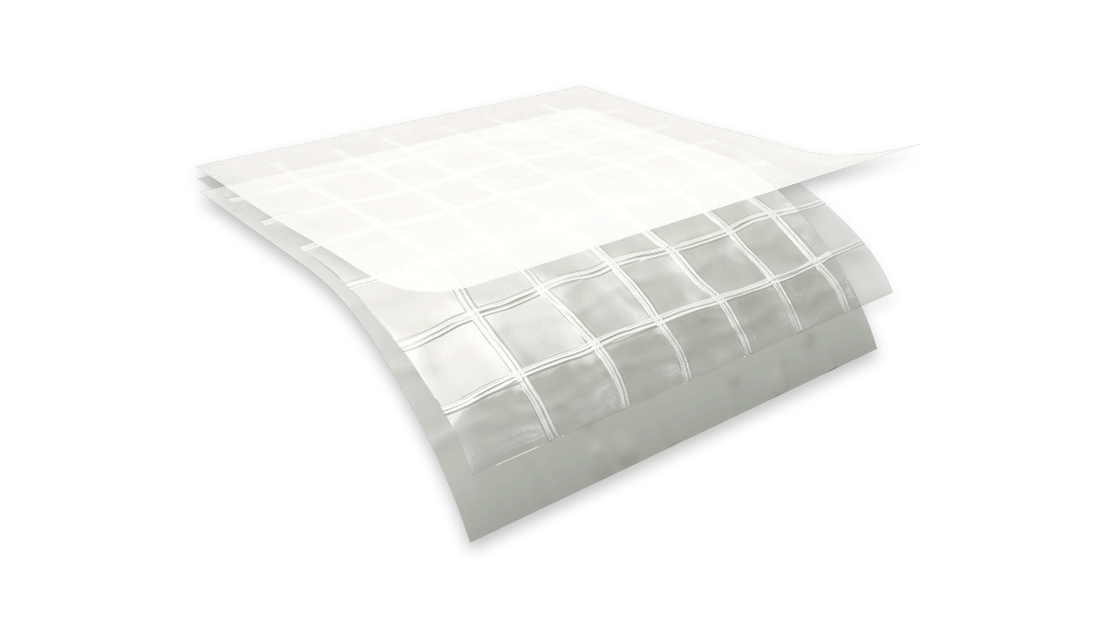

f e a t u r e s a n d b e n e f i t s
TE CHN ICA L D A T A SHE ET
P h y s i c a l p r o p e r t i e s a n d t y p i c a l v a l u e s

griffo lyn ®
tx-1200
P r o p e r t y | A s t m t e s t m e t h o d | u . s . v a l u e | m e t r i c v a l u e
Weight | D-751 | 38 LB/1000 FT2 | 18.6 KG/100 M2
3” Load @ Yield | D-882 | 92 LBF | 409 N
3” Load @ Break | D-882 | 65 LBF | 289 N
 |  | 3050 PSI | 21 MPA
3” Elongation @ Break | D-882 | 450 % | 450 %
Tongue Tear | D-2261 | 21 LBF | 93 N
Trapezoidal Tear | D-4533 | 25 LBF | 111 N
PPT Resistance | D-2582 | 31 LBF | 138 N
Dart Impact Strength | D-1709 | 1.6 LBS | 730 G
Cold Impact Strength | D-1790 | -40°F | -40°C
Permeance | E-96 | 0.047 Grain/Hr•Ft2•in.Hg | 2.70 NG/(PA•S•M2)

d e s c r i p t i o n
Griffolyn® TX-1200 is a 3-ply laminate combining two layers of linear low density polyethylene and a high-strength cord grid. It is specifically engineered to provide high strength and durability in a lightweight material.

- Multiple layers and cord reinforcement resist punctures and tears.
- UV stabilization protects the material from degradation during extended exposure to sunlight.
- Cold-crack resistance eliminates failures in extremely cold temperatures.
- Low permeability greatly inhibits moisture transmission.
- Flexibility and light weight allow for easy handling and quick installation.
MORE
- Custom fabrication is available to meet your exact specifications.
- Long life expectancy allows for significant cost savings through reuse and fewer replacements.
- Class C, ASTM E-1745-11 Standard Specification for water vapor retarders used in contact with soil or granular fill under concrete slabs.

OUR CUSTOMERs DON’T JUST cover their business,
THEY PROTECT IT

MADE IN
- S. A.

TE CHN ICA L D A T A SHE ET
GRIFFO LYN ®
tx-1200

S u g g e s t e d a p p l i c a t i o n s
  - Pallet, cable reel and drum covers for outside storage.
  - Custom bags and tubing.
  - Temporary walls, plant dividers, building enclosures and containment tents.
  - Shipping container covers and liners.
  - Floor covers, dust partitions and cleanroom enclosures.
  - Soil covers to control leachate for stockpiles and landfills.
  - Agricultural storage systems, hay covers and windbreaks.
  - Athletic field and equipment covers.
  - Interim landfill covers
  - Architectural vapor retarder for underslab, walls, ceilings and in roofing systems.

O r d e r i n g I n f o r m a t i o n
AVAILABLE COLORS:
Black, White, and Clear

Custom sizes up to 200’ x 300’ and custom fabrication are available to meet your exact specifications. USABLE TEMPERATURE RANGE:
Minimum: -45°F -42°C Maximum: 170°F 77°C

o u t d o o r e x p o s u r e
Under normal continuous exposure the average life expectancy ranges from 30 to 48 months.

Reef Industries, Inc.
9209 Almeda Genoa Rd. • Houston, Texas 77075 P: 713.507.4251 • F: 713.507.4295
E-mail: ri@reefindustries.com • www.reefindustries.com
toll free 1.800.231.6074
The information provided herein is based upon data believed to be reliable. All testing is performed in accordance with ASTM standards and procedures. All values are typical and nominal and do not represent
either minimum or maximum performance of the product. Although the information is accurate to the best of our knowledge and belief, no representation of warranty or guarantee is made as to the suitability or
completeness of such information. Likewise, no representation of warranty or guarantee, expressed or implied, or merchantability, fitness or otherwise, is made as to product application for a particular use.

©2012 REEF INDUSTRIES, INC. Griffolyn is a registered trademark of Reef Industries, Inc. 10-12

