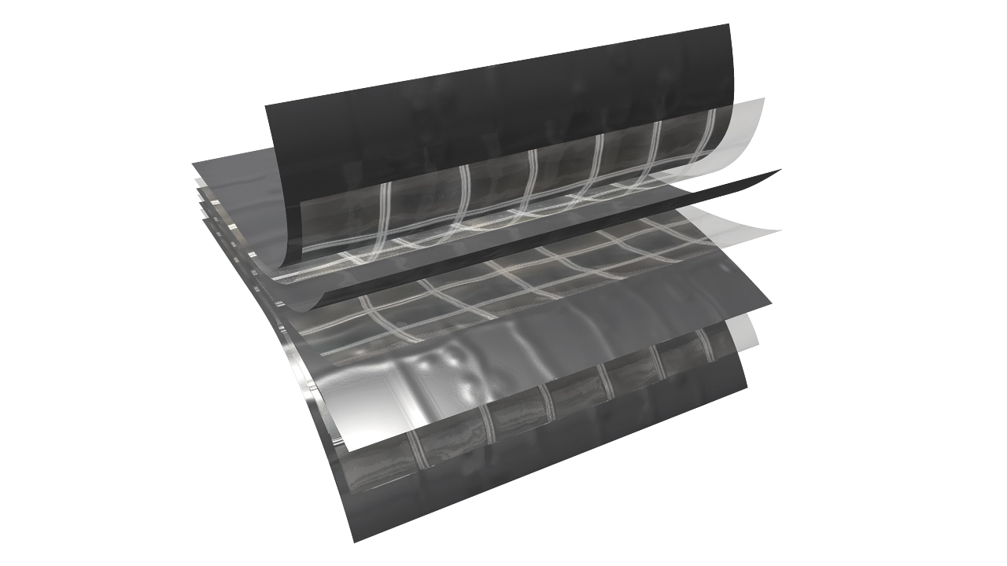

f e a t u r e s a n d b e n e f i t s
TE CHN ICA L D A T A SHE ET
P h y s i c a l p r o p e r t i e s a n d t y p i c a l v a l u e s

griffo lyn ®
type - 105
P r o p e r t y | A s t m t e s t m e t h o d | u . s . v a l u e | m e t r i c v a l u e
Weight | D-3776 | 90 LB/1000 FT2 | 44 KG/100 M2
3” Tensile Strength | D-882 | 275 LBF | 1223.2 N
Puncture Strength | D-4833 | 79 LBF | 351 N
PPT Resistance | D-2582 | 62 LBF | 270 N
Dart Impact Strength | D-1709 | 5.0 LBS | 2300 g
Cold Impact Strength | D-1790 | -40°F | -40°C
Permeance | E-96 | 0.019 Grain/Hr•Ft2•in.Hg | 1.207 NG/(PA•S•M2)

d e s c r i p t i o n
Griffolyn® Type-105 is a 7-ply laminate combining four layers of high density polyethylene and three high-strength cord grids. It is specifically engineered to provide high strength and durability in a lightweight material.

- Multiple layers and cord reinforcement resist punctures and tears.
- UV stabilization protects the material from degradation during extended exposure to sunlight.
- Cold-crack resistance eliminates failures in extremely cold temperatures.
- Chemically resistant to withstand exposure without significant deterioration.
- Low permeability greatly inhibits moisture transmission.
- Flexibility & light weight allow for easy handling and quick installation.
- High durability allows for significant savings through reuse and fewer replacements.
- Class A, ASTM E-1745-11 Standard Specification for Water Vapor Retarders Used in Contact With Soil or Granular Fill Under Concrete Slabs.
MORE

OUR CUSTOMERs DON’T JUST cover their business,
THEY PROTECT IT

MADE IN
- S. A.

TE CHN ICA L D A T A SHE ET
GRIFFO LYN ®
Type - 105

S u g g e s t e d a p p l i c a t i o n s
  - Prairie dog barriers.
  - Pallet, cable reel and drum covers for outside storage.
  - Floor covers, dust partitions and cleanroom enclosures.
  - Temporary walls, plant dividers, building enclosures and containment tents.
  - Architectural vapor retarder for under slab, walls & ceilings and in roofing systems.
  - Shipping container covers and liners.
  - Soil covers to control leachate for stockpiles and landfills.
  - Erosion control and slope protection covers.
  - Agricultural storage systems, hay covers and windbreaks.
  - Athletic field and equipment covers.

O r d e r i n g I n f o r m a t i o n
AVAILABLE COLORS:
Black

SIZES:
Rolls are available from 4’ x 100’ to 40’ x 100’ in increments of 4’ widths. Some sizes available for immediate shipment. Standard length and width tolerances are ± 1% (minimum 2”)
Custom sizes up to 100’ x 200’ and custom fabrication are available to meet your exact specifications. USABLE TEMPERATURE RANGE:
Minimum: -45°F -42°C
Maximum: 170°F 77°C

o u t d o o r e x p o s u r e
Under normal continuous exposure the average life expectancy ranges from 30 to 48 months.

Reef Industries, Inc.
9209 Almeda Genoa Rd. • Houston, Texas 77075 P: 713.507.4251 • F: 713.507.4295
E-mail: ri@reefindustries.com • www.reefindustries.com
toll free 1.800.231.6074
The information provided herein is based upon data believed to be reliable. All testing is performed in accordance with ASTM standards and procedures. All values are typical and nominal and do not represent
either minimum or maximum performance of the product. Although the information is accurate to the best of our knowledge and belief, no representation of warranty or guarantee is made as to the suitability or
completeness of such information. Likewise, no representation of warranty or guarantee, expressed or implied, or merchantability, fitness or otherwise, is made as to product application for a particular use.

©2012 REEF INDUSTRIES, INC. Griffolyn is a registered trademark of Reef Industries, Inc. 10-12

