griffo lyn ®
Pipeboot

TE CHN ICA L D A T A SHE ET

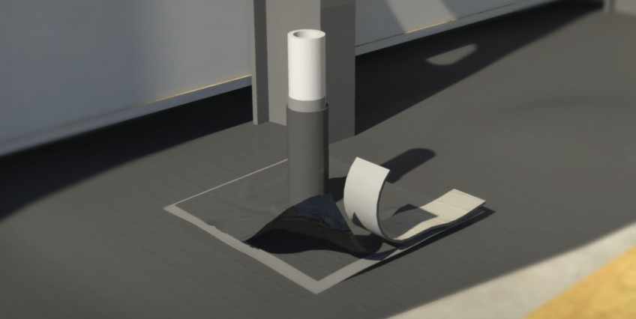
d e s c r i p t i o n
Diameter
12”
Cylinder
APRON
24”
24”
This accessory is typically fabricated with a cylindrical sleeve welded to a flat flange. Standard uses are for placement over pipe penetrations on a vapor retarders. Pipeboots can be fabricated in a variety of diameters or custom made to fit around rectangular columns.

Pipeboot installation requires Fab Tape™

PART No. | LAYFLAT | DIAMETER | PIPE RANGE | APRON
60-0075 | 5” | 3” | 1/2” to 2-1/2” | 24” x 24”
60-0076 | 8” | 5” | 2-1/2” to 4-1/2” | 24” x 24”
60-0116 | 14” | 8” | 4-1/2” to 8” | 24” x 24”

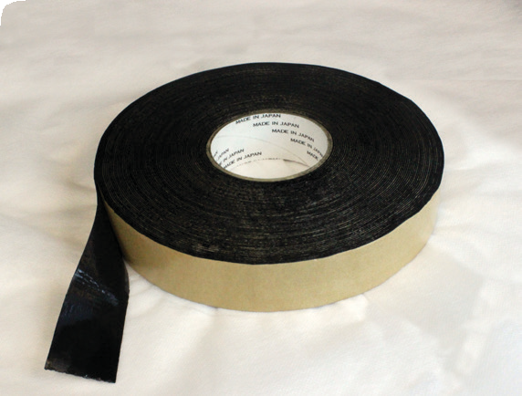
fab tape™
ACCESSORIES
This tape is a double-sided, reinforced black butyl tape for splicing applications.
Ideal for applications where a seal is required between overlapping panels of material. Fab Tape™ comes with a release liner.

Rolls are 1.5” wide × 100’ in length.

OUR CUSTOMERs DON’T JUST cover their business,
THEY PROTECT IT
MADE IN
U. S. A.

Reef Industries, Inc.
9209 Almeda Genoa Rd. • Houston, Texas 77075 P: 713.507.4251 • F: 713.507.4295
E-mail: ri@reefindustries.com • www.reefindustries.com
toll free 1.800.231.6074
The information provided herein is based upon data believed to be reliable. All testing is performed in accordance with ASTM standards and procedures. All values are typical and nominal and do not represent
either minimum or maximum performance of the product. Although the information is accurate to the best of our knowledge and belief, no representation of warranty or guarantee is made as to the suitability or
completeness of such information. Likewise, no representation of warranty or guarantee, expressed or implied, or merchantability, fitness or otherwise, is made as to product application for a particular use.

©2013 REEF INDUSTRIES, INC. Griffolyn is a registered trademark of Reef Industries, Inc. 09-13

