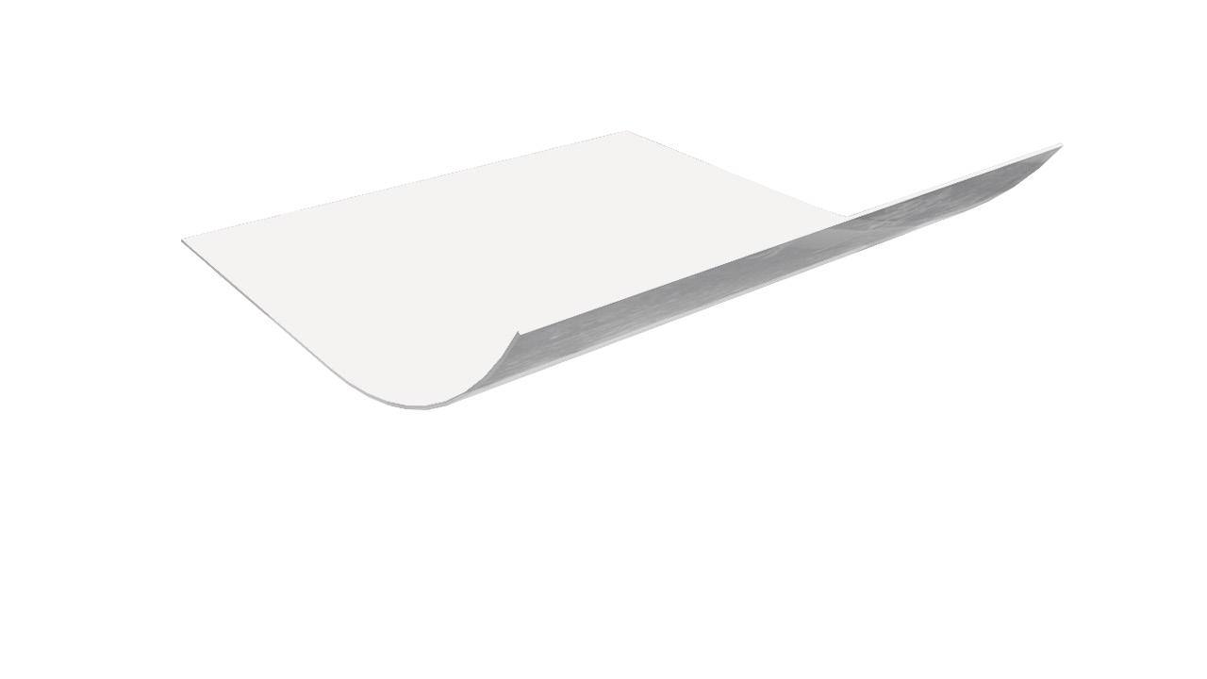

I N S T A L L A T I O N
TE CHN ICA L D A T A SHE ET
P h y s i c a l p r o p e r t i e s a n d t y p i c a l v a l u e s

griffo lyn ®
griff tape™ fr
P r o p e r t y | U . S . V A L U E | M E T R I C V A L U E
Roll Length | 180 Ft | 55 M
Roll Weight | 3.75 LBS | 1.7 KG
Width | 4 IN | 100 MM
Adhesion to Steel | 66 OZ/IN | 72 G/MM
Adhesion to Backing | 41 OZ/IN | 45.9 KG/CM
Tensile Strength | 26 LBS/IN | 4.5 KG/CM
FR Rating:  Vertical Burn TIme 60 Sec. | 0.5 Sec. | 0.5 Sec.
Vertical Burn Drip 60 Sec. | No Drip | No Drip
Vertical Burn Length 60 Sec. | 5 IN | 127 MM

d e s c r i p t i o n
Griffolyn® Griff Tape™ FR is a fire retardant pressure sensitive tape. Tape color is white.

The surface to be taped should be clean and dry. The tape will not adhere if the surfaces are not properly prepared. Dirty or wet surfaces should be completely cleaned with water, paper towels, dry rags or other materials which will prepare the surface for the tape. Accumulations of dust should also be removed to insure a secure seam.

The product obtains optimum adhesion when the surfaces to be bonded are warm. The surfaces should be above 50-60°F to insure an acceptable bond. In order to obtain a bond at lower temperatures, external heat may be required. The use of an industrial style hot air blower is one recommended method. Extra care should be taken when attempting to install tape at temperatures below 32°F.

OUR CUSTOMERs DON’T JUST cover their business,
THEY PROTECT IT
MADE IN
U. S. A.

Reef Industries, Inc.
9209 Almeda Genoa Rd. • Houston, Texas 77075 P: 713.507.4251 • F: 713.507.4295
E-mail: ri@reefindustries.com • www.reefindustries.com
toll free 1.800.231.6074
The information provided herein is based upon data believed to be reliable. All testing is performed in accordance with ASTM standards and procedures. All values are typical and nominal and do not represent
either minimum or maximum performance of the product. Although the information is accurate to the best of our knowledge and belief, no representation of warranty or guarantee is made as to the suitability or
completeness of such information. Likewise, no representation of warranty or guarantee, expressed or implied, or merchantability, fitness or otherwise, is made as to product application for a particular use.

©2013 REEF INDUSTRIES, INC. Griffolyn is a registered trademark of Reef Industries, Inc. 01-13

