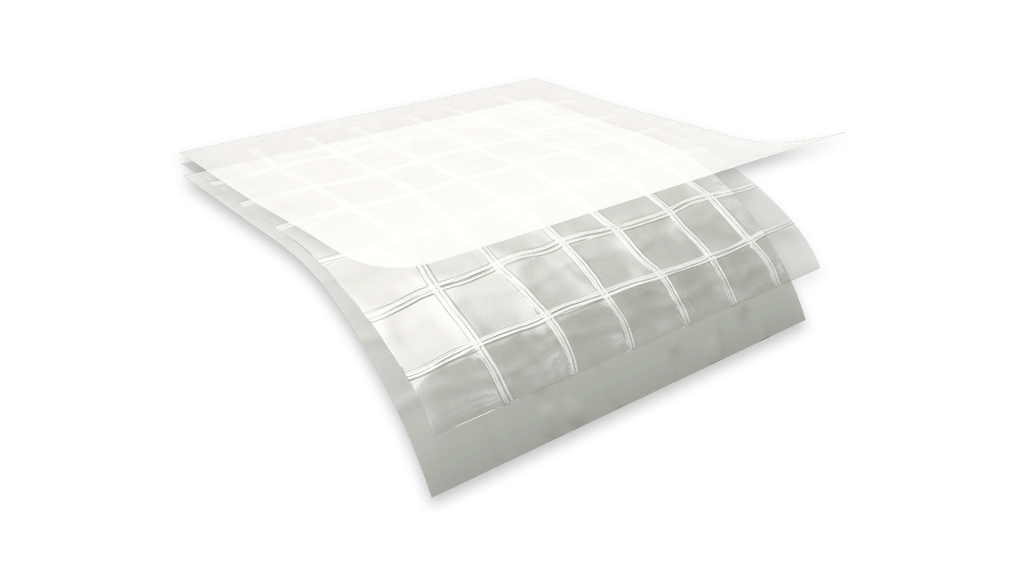

o r d e r i n g i n f o r m a t i o n
TE CHN ICA L D A T A SHE ET
P h y s i c a l p r o p e r t i e s a n d t y p i c a l v a l u e s

griffo lyn ®
20 mil reinforced
P r o p e r t y | A s t m t e s t m e t h o d | u . s . v a l u e | m e t r i c v a l u e
Weight | D-751 | 93 LB/1000 FT2 | 45 KG/100 M2
3” Load @ Yield | D-882 | 130 LBF | 578 N
3” Elongation @ Break | D-882 | 400 % | 400 %
Tongue Tear | D-2261 | 39 LBF | 173 N
Trapezoidal Tear | D-4533 | 55 LBF | 245 N
Permeance | E-96 | 0.014 Grain/Hr•Ft2•in.Hg | 0.80 NG/(PA•S•M2)

d e s c r i p t i o n
Griffolyn® 20 Mil Reinforced is a multiply laminate combining U.V. stabilized film with a high strength cord grid. It is specifically engineered to provide high strength and durability in a lightweight material.

AVAILABLE COLORS: White
Custom sizes up to 100’ x 200’ and custom fabrication are available to meet your exact specifications.

USABLE TEMPERATURE RANGE:
Minimum: -40 °F -40°C
Maximum: 170 °F 77°C

OUR CUSTOMERs DON’T JUST cover their business,
THEY PROTECT IT
MADE IN
U. S. A.

Reef Industries, Inc.
9209 Almeda Genoa Rd. • Houston, Texas 77075 P: 713.507.4251 • F: 713.507.4295
E-mail: ri@reefindustries.com • www.reefindustries.com
toll free 1.800.231.6074
The information provided herein is based upon data believed to be reliable. All testing is performed in accordance with ASTM standards and procedures. All values are typical and nominal and do not represent
either minimum or maximum performance of the product. Although the information is accurate to the best of our knowledge and belief, no representation of warranty or guarantee is made as to the suitability or
completeness of such information. Likewise, no representation of warranty or guarantee, expressed or implied, or merchantability, fitness or otherwise, is made as to product application for a particular use.

©2012 REEF INDUSTRIES, INC. Griffolyn is a registered trademark of Reef Industries, Inc. 10-12

